**EMA Name__________________________________**

**Exponent Rules Date___________________Period__________**

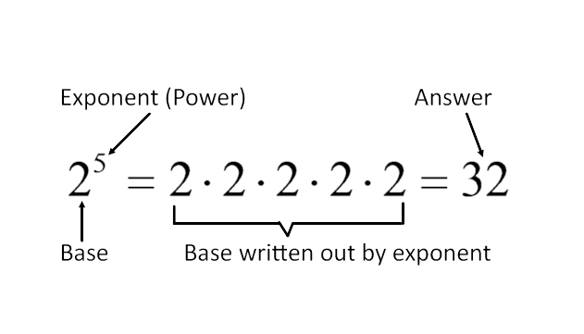

**Exponents**

***Practice***

1.  2.  3. 

4.  5.  6. 

**Power of One and Zero as an Exponent**









***FORMULAS***

Therefore….  and 

***Practice***

7.  8.  9.  10. 

11.  12.  13. = 14. 

**Negative Exponents**

**\*\*\*Can NEVER, EVER have a negative exponent.**

***FORMULA***

 

***Practice***

15.  16.  17. 

18.  19.  20. 

21.  22.  23. 

***FORMULA***



24.  25.  26. 

27.  28.  29. 

30. 31. = 32.

**Multiplying Powers With Same Base**

***FORMULA***

33.  34.  35. 

36.  37.  38. 

39.  40.  41. 

**Power of a Power**

***FORMULA***



42.  43.  44. 

45.  46.  47. 

48.  49.  50. 

**Raising a Product to a Power**

***FORMULA***



51.  52.  53. 

54.  55.  56. 

57.  58.  59. 

**Dividing Exponents with Same Base**

***FORMULA***



60.  61. 62.

63. 64. 65.

**Raising a Quotient to a Power**

***FORMULA***

66. 67. 68.

69. 70.) 71.)

**Exponent Rules - Recap**

$a^{0}=$ $\frac{1}{a^{-1}}=$

${\left(a^{m}\right)}^{n}=$ ${\left(a^{m}b^{m}\right)}^{n}=$

${\left(\frac{a^{m}}{b^{m}}\right)}^{n}=$ $\frac{a^{m}}{a^{n}}=$

$a^{-1}=$ $a^{m}⋅a^{n}=$